Kindertag / Children’s Day

May 3rd
Bring your lawn chairs!
6 – 8pm
Orange Hunt Playground
Featuring the
Alte Kameraden

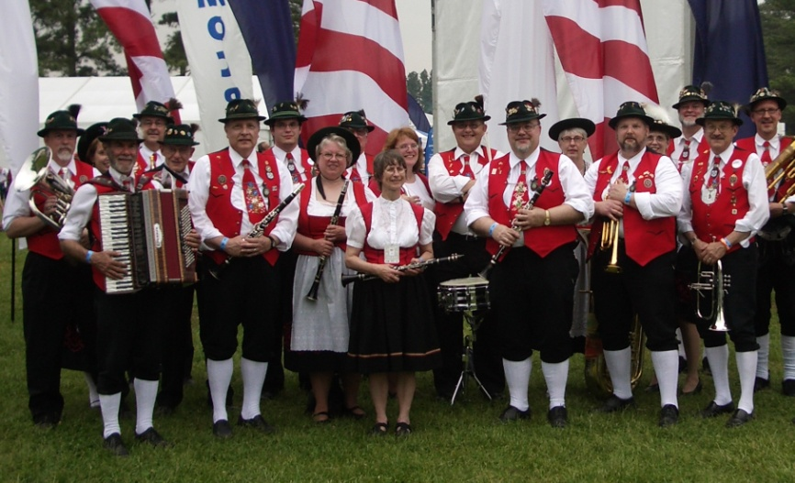

Performances by the Boyle School of Irish Dance
and the OHES Kinderchor
Food for purchase
Games
May Pole

Family Fun

Volunteers needed please email kindertag@orangehuntpta
